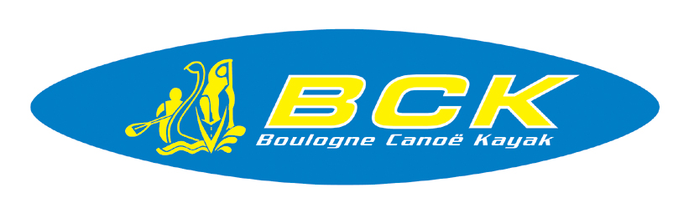

REGISTRATION, MEALS & ACCOMODATION
INTERNATIONAL RACE OF PAS DE CALAIS

Name / Country : ……………………………………………………………………………………….

Number of Athlets : ……………………… Number Team Leader : ………………………

Contact (name + email + phone) :
……………………………………………………………………………………………………………………………………………………………………………….………………………………………………………………………………………..

Accomodation :
- Pack IBIS
- Pack Mont de Couppes

- Pack IBIS

- Night of ……………………………… x ………. Twin rooms = ………… people
x ……….. Single rooms = ………… people
+ ………. Meal of …………………………….. & of ……………………………….. (Day)

- Night of ……………………………… x ………. Twin rooms = ………… people
x ……….. Single rooms = ………… people
+ ………. Meal of …………………………….. & of ……………………………….. (Day)

- Night of ……………………………… x ………. Twin rooms = ………… people
x ……….. Single rooms = ………… people
+ ………. Meal of …………………………….. & of ……………………………….. (Day)

- Pack MONT DE COUPPES

- Night of ……………………………… x ………. Bed
+ ………. Meal at Nautic Stadium : …………………………………………………..….…. (Day)
+ ………. Meal at Mont de Couppes : …………………………………….………….. (Day)

- Night of ……………………………… x ………. Bed
+ ………. Meal at Nautic Stadium : …………………………………………………..….…. (Day)
+ ………. Meal at Mont de Couppes : …………………………………….………….. (Day)

- Night of ……………………………… x ………. Bed
+ ………. Meal at Nautic Stadium : …………………………………………………..….…. (Day)
+ ………. Meal at Mont de Couppes : …………………………………….………….. (Day)

………..

File to be sent by mail before 18 March 2019

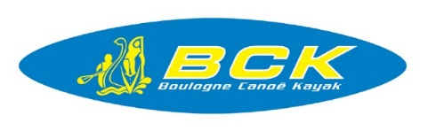

BOULOGNE CANOE KAYAK
7 Boulevard Chanzy 62200 - Boulogne/Mer
FRANCE
Email: inscription@boulogneck.fr / commercial@boulogneck.fr
Site web: www.boulogneck.fr
Tel : 333.21.31.98.60

